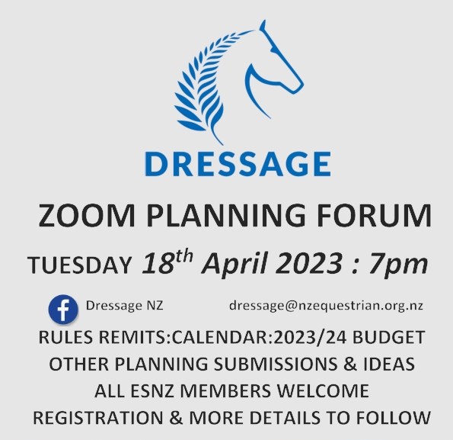

If all business is not concluded then a second session will be held on Wednesday 19th at 7pm
INSTRUCTIONS
- Remits and agenda items will only be accepted as a word document completed on the templates on pages 2 & 3
- Handwritten remits and photos will not be accepted
- No submissions will be accepted after 5pm Friday 17th March. This will be strictly enforced
- All submissions must be emailed to dressage@nzequestrian.org.nz
- Any queries to dressage@nzequestrian.org.nz

DRESSAGE NZ PLANNING FORUM APRIL 2023
REMIT: AMENDMENT TO DRESSAGE RULES

I, ............................................................................................................................................(name)
Dressage NZ Committee member: (Specify role).................................................................
Full Financial Member ESNZ (specify any official role).........................................................
Specify if on behalf of an official Dressage Group or Branch...............................................
Request that this remit be put forward to the 2023 Dressage NZ Planning Forum:
Signed..................................................................................................................................
Seconded by (name & signature ) – must be current financial member
:.............................................................................................................................................

CURRENT RULE/ARTICLE NUMBER :
NEW Y / N
Add/Amend /Delete
REMIT:

RATIONALE: (Add separate pages or attachments if necessary)

DRESSAGE NZ PLANNING FORUM APRIL 2023
AGENDA ITEM / PROPOSAL

I, ..........................................................................................................................................(name)
Dressage NZ Committee member: (Specify role)................................................................
Full Financial Member ESNZ (specify any official role).........................................................
Specify if on behalf of an official Dressage Group or Branch...............................................
Request that this topic/proposal be added to the agenda of the 2023 Dressage NZ Planning forum:
Signed..................................................................................................................................

TOPIC: ......................................................................................................
Proposal and / or Rationale for Forum Discussion:
(Add separate pages or attachments if necessary)

