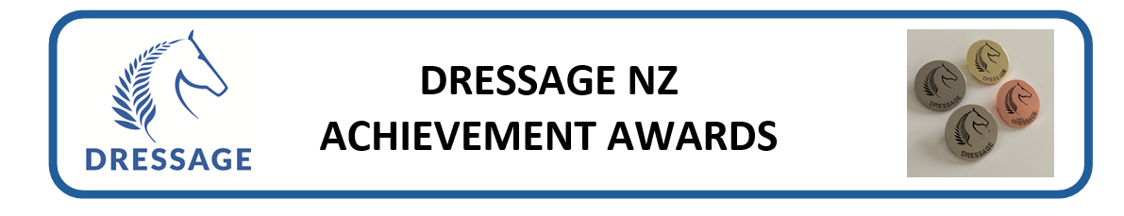
Questio ns – Prelim/Novice
Compulsory questions for award:

ELITE AWARD

Rider Name |  | ESNZ #:
Email |  | Mob:
Horse/Pony |  | ESNZ#:
Event |  | Date
Venue
Test 1 Name |  | %
Test 2 Name |  | %
Test 3 Name |  | %

On completion email in word or .pdf format. Photos not accepted. Or post to one of the assessors.

Rider Achievement Award Assessors
Andrea Raves | 12B Ceres Crescent | Wellington 6037 tetch@xtra.co.nz
Bill Noble | 47 Ringer Rd | RD7 | Hamilton 3287 safbnoble@xtra.co.nz
Philip Oxenius | 2 Coastal Court | Longbay |Auckland 0630 poxenius@gmail.com

