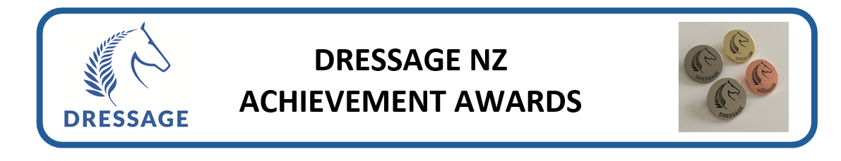
Questio ns – Prelim/Novice
Compulsory questions for award:

DEVELOPMENT AWARD

Rider Name |  | ESNZ #:
Email |  | Mob:
Horse/Pony |  | ESNZ#:
Event |  | Date
Venue
Test 1 Name |  | %
Test 2 Name |  | %
Test 3 Name |  | %

On completion email in word or .pdf format. Photos not accepted. Or post to one of the assessors.

Rider Achievement Award Assessors
Andrea Raves | 12B Ceres Crescent | Wellington 6037 tetch@xtra.co.nz
Bill Noble | 47 Ringer Rd | RD7 | Hamilton 3287 safbnoble@xtra.co.nz
Philip Oxenius | 2 Coastal Court | Longbay |Auckland 0630 poxenius@gmail.com

QUESTIONS – PART 1
- Name and explain the “Scale of Training”?
- Why is it important to follow it?

QUESTIONS – PART 2

Answer any three of the questions below:
- What is the difference between a free walk on a long rein and extended walk?
- Why is shoulder-in sometimes called the “mother of all exercises”?
- What purpose does a “simple change through the walk” have?
- When, and why, do we introduce a double bridle?

