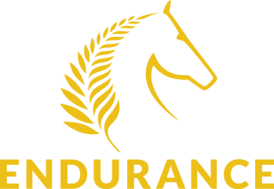

The following four questions must be answered by Board candidates and returned with nomination form.
- What are your objectives or goals for joining the Endurance Board?

- If you were to join the Endurance Board – what would you like to achieve during your time on the Board?

- What skills, connections, resources and expertise do you have to offer to the Endurance Board?

- What do you see as the top priorities for the Endurance Board?

