OFFICIAL SADDLECLOTH BADGE OF ESNZ PARA EQUESTRIAN

All Classified Para riders must have one of these badges each side of the horse at all competitions for lunging, schooling, hacking, and competing.

Horse and Pony Identification Requirements.
All Classified Para Equestrian riders must display the “Official Orange ESNZ Para Equestrian Badge” on both sides of the saddle cloth at all times whilst
hacking, lunging, schooling, exercising and competing in all ESNZ affiliated disciplines when the horse/ pony is under saddle.

As per Para Equestrian rules.
The Para Equestrian badges must be the official Para Equestrian logo as below. Orange fill with black outline. The disc must be no smaller that 7cm and no larger than 8cm in diameter. Sew-on cloth badges are available from ESNZ for $40 per set or make your own as follows.
Option 1. Para Equestrian badge only.
Option 2. Para Equestrian badge combined with bridle number.
Print the document page in colour and cut out each individual image. This will mean a tight seal around each badge when you cut them out again after laminating. Lay onto a laminating pouch and laminate.
Either affix a large nappy pin with a piece of duct tape onto the back or stick the rough piece of Velcro onto the back and sew the fluffy side onto your saddlecloth. Makes for easy removal of the badge and washing of the saddlecloth.

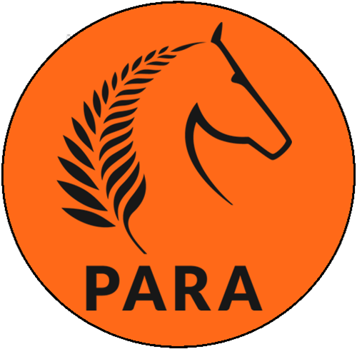
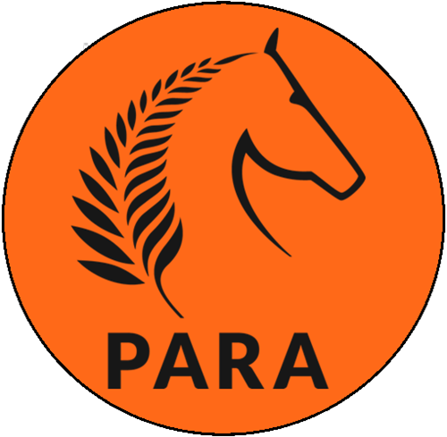
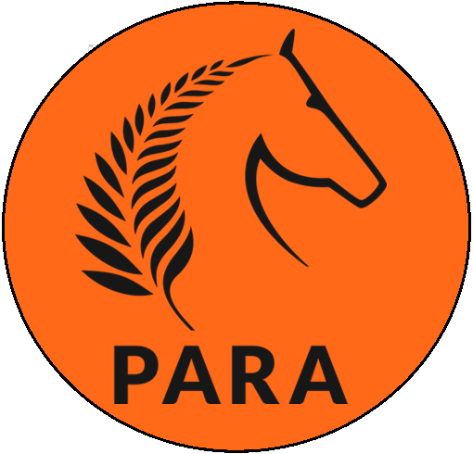
Option 1

Option 2
The example below is ESNZ approved. For ease of attachment edit by changing the digits to your own horse’s registration number and laminate to create as many sets of numbers that you need for hacking, schooling and competition at events.
123456
123456
123456

