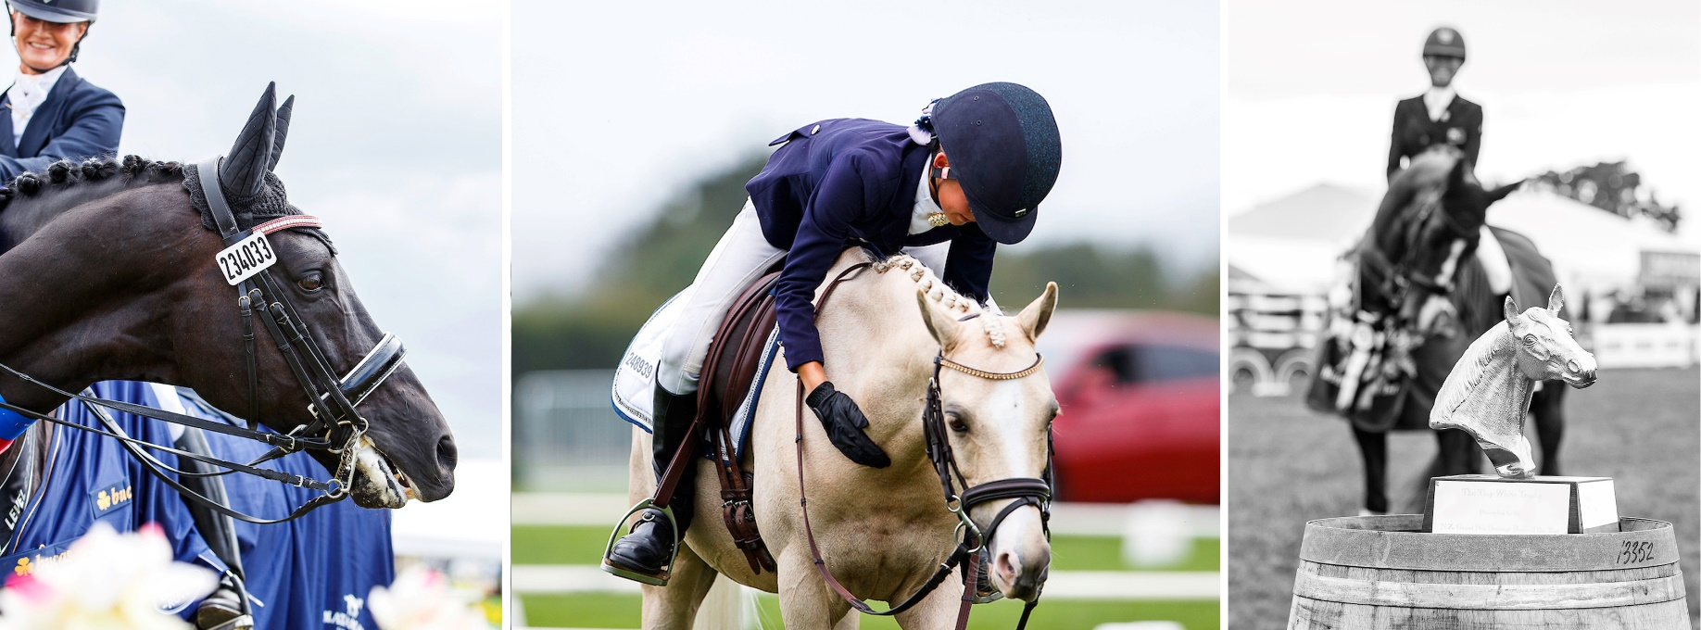
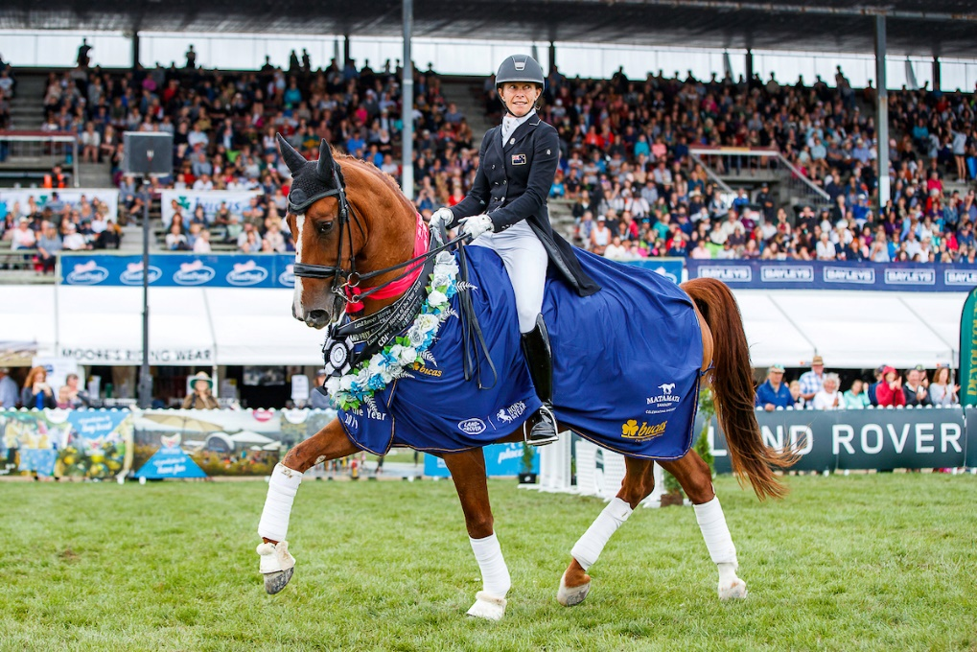

29th June 2019 - Dressage NZ AGA - Conference
“Fashion in the Field” Awards Dinner
Prizes for Best Dressed Lady, Gent & Couple
Great Entertainment & Celebrations & Auctions

Timetable:
Friday 28th June: Board Meeting
Saturday 29th June: Conference 10am – 4pm Registration and Coffee from 9.00am
Awards Dinner Meet & Greet from 5.45pm in the bar
Awards Dinner from 6.30pm with Presentations from 6.45 pm
Sunday 30th June: Committee Meeting 8.30am – Lunch at 12.45pm (Observers welcome)
Registrations essential. Close 24th May
Sudima Hotel - Auckland Airport
DRESSAGE NEW ZEALAND
2019 AGM – CONFERENCE, AWARDS DINNER & COMMITEE
Saturday 29th | Sunday 30th June:
Hosted by Auckland Manukau and Waitemata Dressage @ Sudima Auckland Airport Hotel
REGISTRATION FORM:
Please Return By 24th May 2019 to: amdgsportmanager@gmail.com

Surname: ................................................. | Initials.. | Known as
Partner Name: ....................................... | Initials | Known as.

Address: ....................................................................................................................................................
Email:......................................................................................................... Mobile....................................
ESNZ Area: .............................................. Delegate YES / NO
Arrival date: Thurs / Fri / Sat Departure date : Sat / Sun
Arrival time eta Hotel: Driving / Flight # Flight arrival time:
On arrival I require Yellow Bus Service to the hotel (free) YES / NO
If you prefer a taxi please organise direct as per instructions on page 4

Saturday 29 June 2019 - CONFERENCE starts at 10.00am. Arrival tea and coffee at 9.15am

Conference (includes lunch, morning/afternoon tea) | $50.00 p/p | $.
Fashion in the Field Awards Dinner | $75.00 p/p | $
Sunday 30 June 2019 - COMMITTEE MEETING 9.00am – Lunch 12. 45pm (Observers very welcome)

Meeting (includes morning tea and lunch) | $30.00 p/p | $
 | TOTAL | $
Specify special dietary requirements:

Internet Banking: Dressage NZ Account: 15 3950 0471176 01 (TSB, Hawera )
Date Paid:……………………………………. Please add your Name and ‘Conf’ in the reference field.
Please send the Conference Registration/Awards Dinner form to: Judy Collin at email below
amdgsportmanager@gmail.com (Any queries to dressage@equestrian.org.nz or Sport Manager 027 240 2702)
**Accommodation MUST be booked directly with the Hotel**
SUDIMA AUCKLAND AIRPORT
18 AIRPARK DRIVE, MANGERE, AUCKLAND 2022
Phone: 09 551-8888

DRESSAGE NEW ZEALAND
ANNUAL CONFERENCE AND AWARDS DINNER
Saturday 29 June/ Sunday 30 June 2019

ACCOMODATION BOOKING FORM

Please book directly with the Sudima Auckland Airport Hotel

Telephone +64 9 551 6339
Website: www.sudimahotels.com/en/our-hotels/auckland-airport/

Accommodation

Room Rate: $179.00 per day/room – Room Only incl GST
Room Type: Superior Twin (2x Double Beds)
Full Cooked Breakfast: $29.00 per person incl GST
PROMO CODE: DRG19

Facilities:

- Pool & Gym available 24 hours
- Public Restroom available (Ladies, Gentleman, Accessible)
- Visaya Restaurant & Bar available
- Smoking area available outside the Hotel (no smoking in the Hotel)
- Room Service available 24 hours (menu available in the room)

GETTING TO SUDIMA AUCKLAND AIRPORT FOR YOUR CONFERENCE
SUDIMA AUCKLAND AIRPORT | 18 AIRPARK DRIVE, MANGERE, AUCKLAND 2022
Phone: 09 551-8888

DRIVING TO THE HOTEL Complimentary Parking based on first come, first serve is available for all guests visiting or staying at the Sudima Auckland Airport. Simply drive in to the hotel and park at any available
spots.
Coming from the airport?
CATCHING THE YELLOW BUS
The Yellow Bus is a shared Airport transfer between selected hotels within 5km radius of the
Auckland Domestic and International Airport.
For more details on the bus route and timetable, please visit their website at
https://www.yellowbus.co.nz/
The Yellow Bus transfer is included in your conference package.
Making your way to the Hotel:
If you require transfers coming to the hotel using this service, please coordinate with your
facilitator to book your space with the hotel conference coordinator.

Making your way to the Airport:
Heading back home? Please advise your facilitator on the day that you require the transfer
service and a ticket will be issued out by our friendly Front Office team.
To and from the Hotel?

TAXI
Alert Taxi is our preferred taxi company that offers a fixed rate of $20 for a 4 seater car and $25
for a van for all our guests, including a meet and greet service upon arrival.
We can arrange this for you, or you can contact them yourself on +64 09 309 2000 and let Alert
Taxi know that you are staying at our Hotel. This service is provided for both travelling to the
Hotel and to the Airport.

