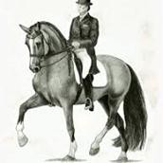DRESSAGE NEW ZEALAND
2018 AGM - CONFERENCE
& AWARDS DINNER
Saturday 30 June and Sunday 1 July 2018
Hosted by Dressage Central Districts
Hotel Distinction - Palmerston North

REGISTRATION FORM - Please Return By 26th May 2018

Surname: ................................................. | Initials............... | Known as..................................
Partner’s Name: ....................................... | Initials............... | Known as.................................

Address: ....................................................................................................................................................

........................................................................................................... Post Code….............................. Email: ....................................................... Phone............................... Mobile..................................... ESNZ Area: ..............................................
Arrival date: Thurs / Fri / Sat Departure date : Sat / Sun

Arrival time eta Hotel: Driving /or Flight # Flight arrival time

Saturday 30 June 2018 - CONFERENCE starts at 10.00am. Arrival tea and coffee at 9.15am

Conference (includes lunch, morning/afternoon tea) | $50.00 p/p | $.........................
Awards Dinner | $85.00 p/p | $.........................
Specify special dietary requirements: ......................................

Sunday 1 July - COMMITTEE MEETING 9.00am – Lunch 12.30pm (Observers are very welcome)

Meeting (includes morning tea and lunch) $30.00 p/p $.........................
TOTAL $......................... Conference and Awards Dinner fees can be paid either by cheque or internet banking (Preferred!)

Please indicate: Cheque Internet Banking

Internet Banking: Dressage NZ Account: 15 3950 0471176 01 (TSB, Hawera )
Date Paid:

Please add your Name and ‘Conf’ in the reference field.
Please send the Conference Registration/Awards Dinner form to: Saskia Brosnan – Dressage Central Districts
Email to: saskia.brosnan@gmail.com (Any queries to Saskia by email or Sport Manager 027 240 2702)

**Accommodation MUST be booked directly with the Hotel**
HOTEL DISTINCTION PALMERSTON NORTH
175 Cuba St, Palmerston North, 4441
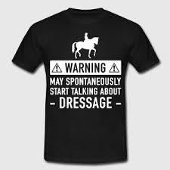
Phone: 06-355 5895

The AWARDS DINNER will again feature the IMPROVISORS – the Wellington Theatre Sports Comedy Act Many of you will remember the hilarious night we had in Wellington a number of years ago. The Awards Dinner THEME will be “Backing Black” and so it will be a black & white or black & silver night showing support for our WEG riders - there will be a DRESS-IT-UP for WEG PRIZE – so dress it up!

