Volunteering
Bates Nationals from the Inside Out
Workshop 2019
__________________________________________________________________________________

As part Dressage NZ’s new volunteer strategy we are offering a rare and exciting opportunity for existing and potential event managers to immerse themselves in a behind the scenes look at Dressage NZ’s flagship event. The show is a two time winner of the sponsor’s choice Show of the Year and has a vastly experienced team of people that work behind the scenes to achieve that high standard. Held over two days at Manfeild DNZ’s Partnerships Facilitator Celine Filbee will facilitate the workshop. As 12 time event manager for the Bates National Championships and numerous other dressage and equestrian events across several disciplines Celine will give workshop attendees an insightful view of the nuts and bolts of the show and they come away with a wealth of information that can be used at other events.

Scope
The workshop will cover the following topics
- Overview of the Event Managers role
- Planning & Preparation for a show
Including Resource requirements, venue & facilities, Health & safety, compliance, volunteers, suppliers, programme, officials roles.
- Schedule Preparation
- Logistics & Timetabling
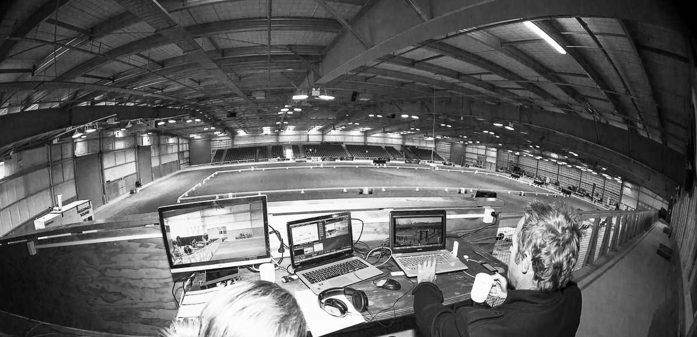
Including arenas, catering, presentations, arena familarisation, scoring
- Health & Safety
Implementation, risk assessment, reporting
- Recruiting and resourcing Volunteers
- Sponsors & Funding
Funding applications, sponsorship proposals, event hospitality

Target Attendees
Premier League and Local Show Event Managers, Event Secretaries wanting to upskill, other suitable individuals with a sound knowledge of Dressage and proven organisational/personal skills.

Dates/Venue
Manfeild Park, Bates Nationals, Saturday 16th & Sunday 17th February 2019.

Cost/
Course attendees/Area Group to pay for travel and accommodation, course attendance is free.

Travel/Accommodation
The nearest Airport is Palmerston North, DNZ will arrange airport collection for those flying.
Accommodation options are South Street West Motel or Manfeild Park Motel both a five minute walk from the venue. Camping available onsite.

Other Information

Prospective attendees must be nominated by their Dressage Area Group.
Workshop places will be limited at the discretion of Dressage NZ.
DNZ reserves the right to accept or decline any application to attend the workshop.
Attendees will be provided a hard copy of the Dressage A to V event Management manual.
Lunch, morning and afternoon tea will be provided.
A full timetable will be provided prior to workshop.
Anticipated start time 8am Saturday, finish time 3pm Sunday.
Attendees will receive one complimentary ticket to the Dressage Musical Spectacular

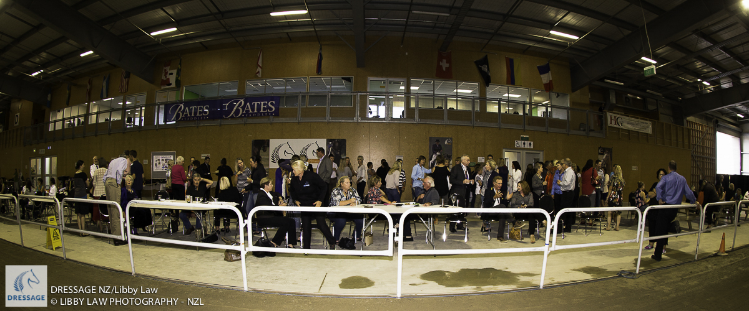

Bates Nationals from the Inside Out
Registration Form
__________________________________________________________________________________

Name Email

Mobile Phone Number Area Group

Name/ Signature of Area President

Please outline any previous event management/secretarial or other relevant experience?

Please outline your business as usual/Job role, including a short summery of your skills and experience.

Reason for attending and special area of interest?

What is your intended use for the workshop learnings?

